-1- Qu'avez vous retenu des documents de la situation problème ?
…………………………………………………………………………………………………
…………………………………………………………………………………………………
…………………………………………………………………………………………………
…………………………………………………………………………………………………
…………………………………………………………………………………………………
…………………………………………………………………………………………………
…………………………………………………………………………………………………
…………………………………………………………………………………………………
…………………………………………………………………………………………………
……………………………………………………………………………………………………………………………………………………………………………………………………
-2- Enoncez clairement le problème de Donald :
…………………………………………………………………………………………………
…………………………………………………………………………………………………
…………………………………………………………………………………………………
-3- L'agglomération de périgueux :
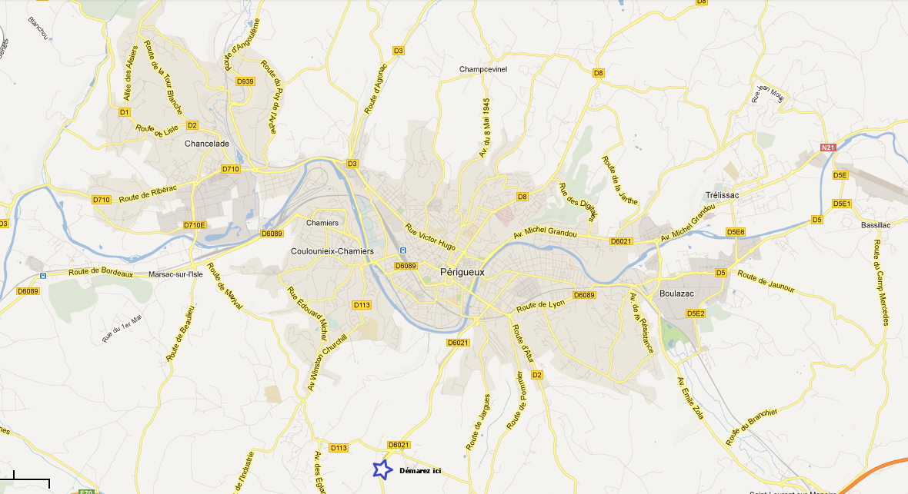
-4- Proposez plusieurs solutions pour résoudre le problème de Donald :
…………………………………………………………………………………………………
…………………………………………………………………………………………………
…………………………………………………………………………………………………
…………………………………………………………………………………………………
…………………………………………………………………………………………………
…………………………………………………………………………………………………
…………………………………………………………………………………………………
…………………………………………………………………………………………………
- Pourquoi faudra t-il forcement construire un ou des ponts pour résoudre notre problème ?
…………………………………………………………………………………………………
…………………………………………………………………………………………………
…………………………………………………………………………………………………
…………………………………………………………………………………………………
- Proposition de nouveaux tracés / Obstacles ?
1Km

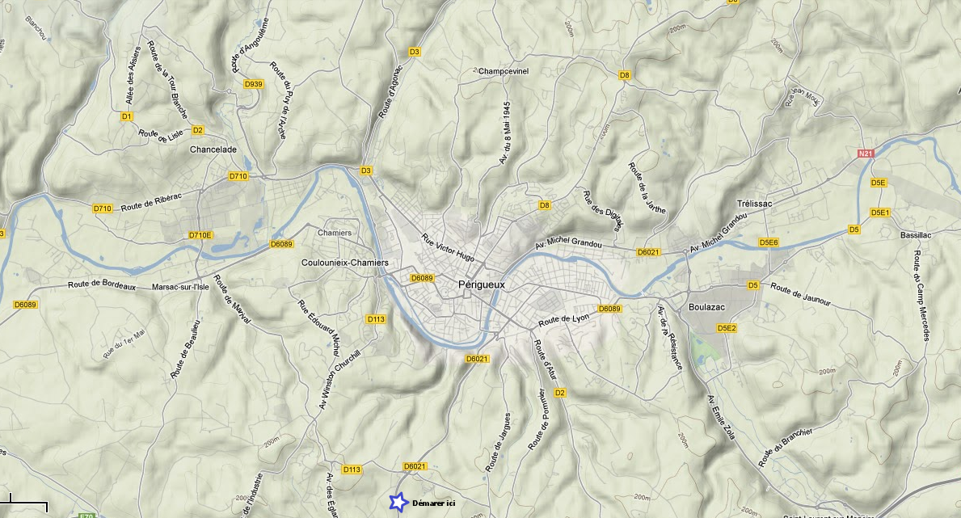

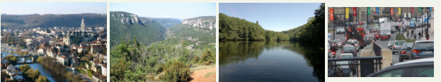
-1-……………………………………………………………………………………………
…………………………………………………………………………………………………
…………………………………………………………………………………………………
…………………………………………………………………………………………………
…………………………………………………………………………………………………
…………………………………………………………………………………………………
…………………………………………………………………………………………………
…………………………………………………………………………………………………

-2- Contraintes :
Photo 1 : …………………………………………………………………………………….
Photo 2 : …………………………………………………………………………………….
Photo 3 : …………………………………………………………………………………….
Photo 4 : …………………………………………………………………………………….

- Choix du type de pont permettant de passer les obstacles ?
(écrire ici vos justifications)
…………………………………………………………………………………………………
…………………………………………………………………………………………………
…………………………………………………………………………………………………
…………………………………………………………………………………………………
…………………………………………………………………………………………………
…………………………………………………………………………………………………
…………………………………………………………………………………………………
…………………………………………………………………………………………………
…………………………………………………………………………………………………
…………………………………………………………………………………………………
……………………………………………………………………………………………………………………………………………………………………………………………………
…………………………………………………………………………………………………
…………………………………………………………………………………………………
……………………………………………………………………………………………………………………………………………………………………………………………………
…………………………………………………………………………………………………
…………………………………………………………………………………………………
…………………………………………………………………………………………………

